IOT Gesture Controlled Car with gas sensor
Abstract:
This project presents an enhanced gesture-controlled car system designed to provide both mobility assistance and environmental safety. Building upon a system that utilizes ESP32 microcontrollers and MPU6050 sensors to translate hand movements into directional commands for vehicle navigation, this innovation integrates gas detection capabilities. A gas sensor (MQ2 Sensor) is incorporated into the system to monitor for hazardous gas levels, triggering an alarm to alert the user. This combined approach offers a valuable solution for individuals requiring mobility support in potentially dangerous environments, expanding the system's utility in applications such as industrial safety, emergency response, and personal safety.
Keywords:
- ESP32
- Gesture Control
- MPU6050
- Smart Mobility
- Bluetooth
Components:
- ESP32 Microcontroller (x2)
- MPU6050 Sensor
- L298N Motor Driver
- Geared DC Motors
- Wheels
- MQ-2 Gas Sensor
- Jumper Wires

Introduction:
In recent years, the development of assistive technologies has significantly advanced, providing innovative solutions to improve the quality of life for individuals with disabilities. Mobility assistance systems, in particular, are vital for ensuring independence and enabling active participation in daily life. Among various human-machine interaction methods, gesture recognition has emerged as a promising and user-friendly technology that allows individuals to control devices through simple hand or wrist movements. This form of interaction eliminates the need for physical interfaces, making it especially suitable for differently abled individuals with limited motor control [1][2].
The integration of microcontroller-based systems such as the ESP32, combined with motion sensors like the MPU6050, has enabled the creation of lightweight, low-cost, and efficient gesture-controlled vehicles. These systems interpret accelerometer and gyroscope data to determine directional commands, which are then used to control the movement of a robotic car or mobility device [3][4]. Bluetooth-based wireless communication allows seamless transmission of control signals between the gesture unit and the vehicle, providing a smooth and responsive driving experience [5].
However, while mobility assistance is crucial, environmental safety also plays a fundamental role in user well-being—particularly in indoor, industrial, or health-sensitive settings. Gas leaks and poor air quality are potential hazards that can have serious health implications. Real-time monitoring and early warning systems for detecting harmful gases such as carbon monoxide, ammonia, and smoke are essential in such scenarios. The MQ-135 gas sensor, known for its broad range of gas detection, can be effectively integrated into mobile systems to provide continuous environmental monitoring [6][7].
Furthermore, the COVID-19 pandemic underscored the importance of health surveillance and early detection mechanisms in public and private environments. Incorporating such features into mobility aids not only ensures physical autonomy but also enhances situational awareness and overall safety [8].
This project proposes a gesture-controlled vehicle enhanced with gas detection capabilities. The system combines mobility support with environmental monitoring to create a smart, responsive, and safety-oriented assistive device. By equipping the car with a gas sensor and a real-time alert mechanism, the project aims to offer a dual-purpose solution—helping differently abled users navigate their surroundings with ease while simultaneously protecting them from potential airborne hazards. The result is a robust platform that addresses both mobility challenges and health risks in a seamless, integrated manner.
Methodology:
The gesture-controlled car system comprises two primary components:
Transmitter Unit: Equipped with an ESP32 and MPU6050 sensor, integrated into a wearable glove to capture hand orientation and transmit data via Bluetooth.
Receiver Unit: Features an ESP32 connected to an L298N motor driver module, responsible for driving the motors based on the received data, and a gas sensor to detect gas levels.
The system works as follows:
- Gesture Capture: The MPU6050 reads pitch and roll data.
- Signal Processing: Data is processed by the transmitter ESP32 to classify gestures.
- Command Translation: Bluetooth Serial sends motion commands to the receiver ESP32.
- Car Control: The receiver ESP32 interprets commands and drives motors via L298N.
- Gas Sensor Integration: Connect the gas sensor to the ESP32 on the receiver unit. The ESP32 continuously reads data from the gas sensor and activates an alarm if a predefined threshold is exceeded.
HAND GESTURE | CAR ACTION
Tilt Forward | Move forward
Tilt Backward | Move Backward
Tilt Left | Move Left
Tilt Right | Move Right
Neutral/Still Position | Stop

Here is a flowchart that will help in better understanding of our Gesture Control Car:
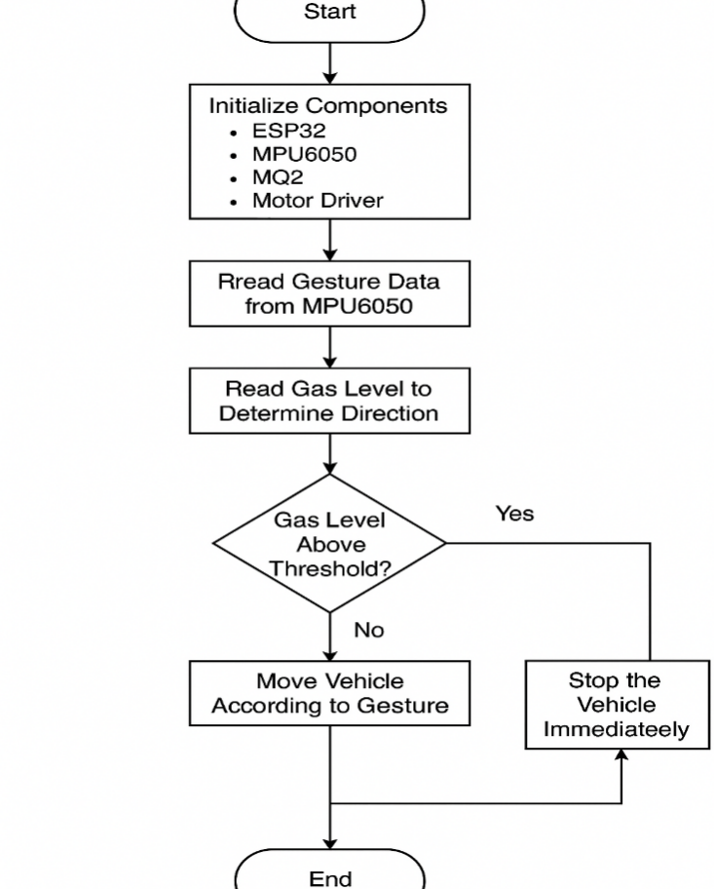

Circuit Diagram for Transmitter:

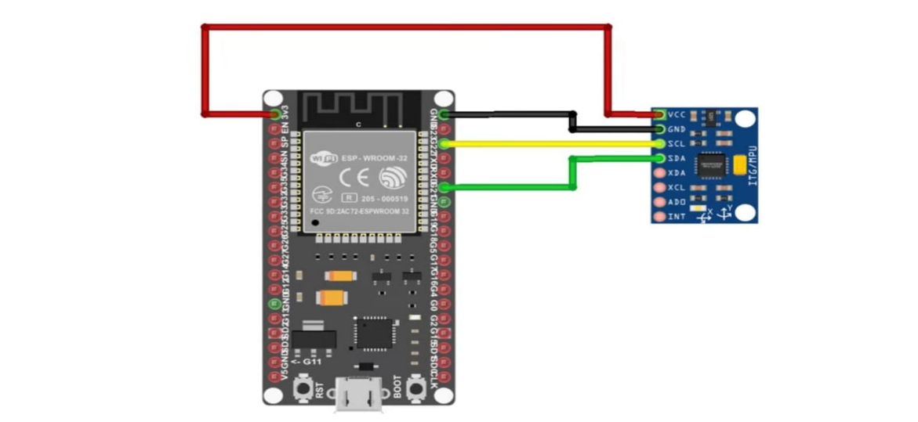

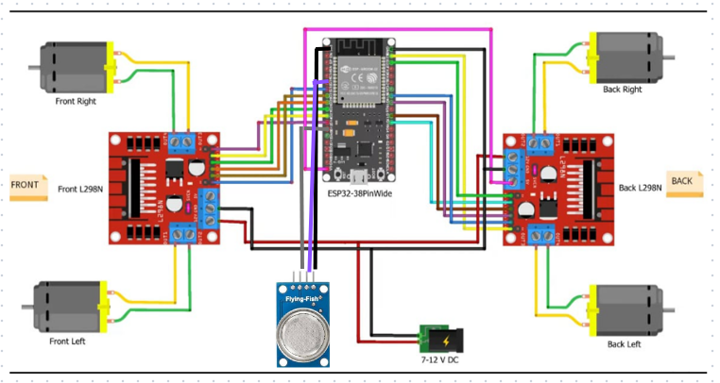
Circuit Diagram for Receiver:

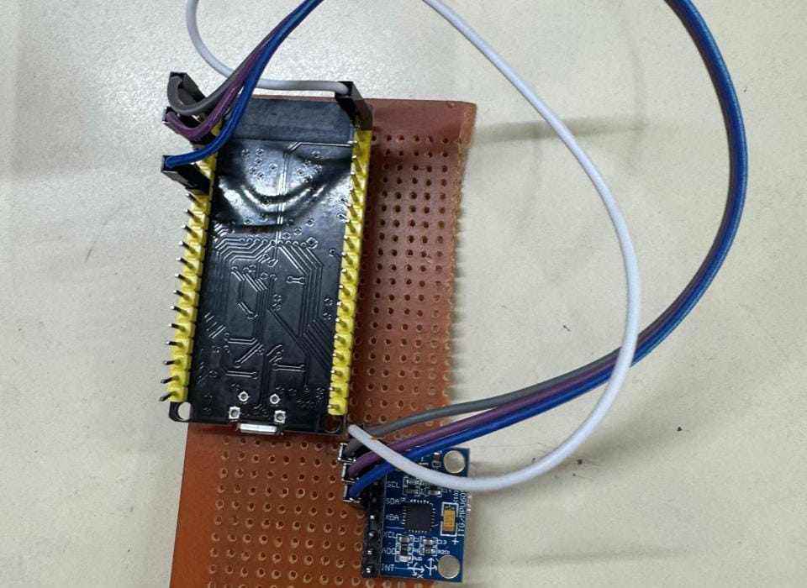
Fig1: View of Transmitter:

Fig2: View of Receiver:
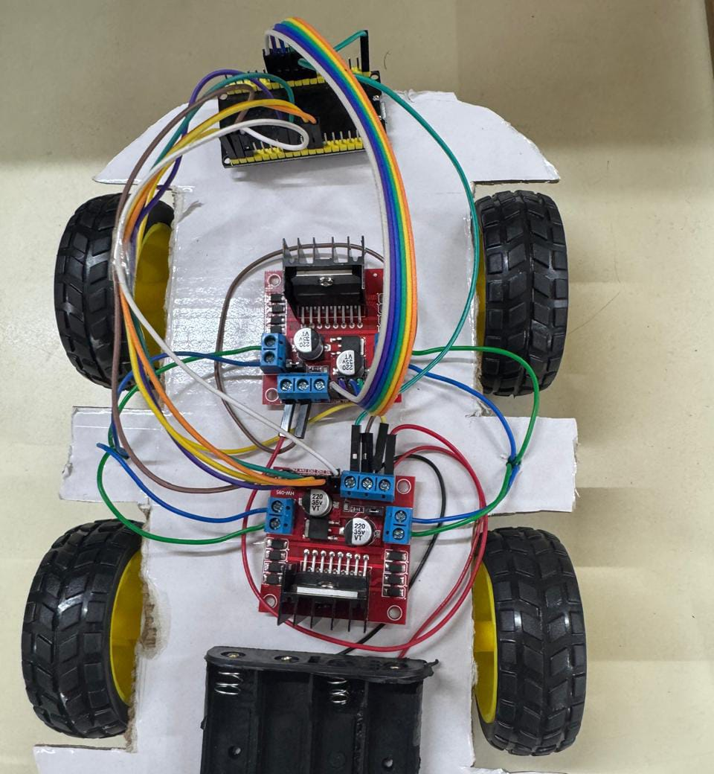
Results:
The gesture-controlled car system was successfully implemented and tested, demonstrating its ability to accurately recognize predefined hand gestures and translate them into driving commands. The system effectively performed basic driving functions such as forward movement, turning, and stopping. Furthermore, the integration of the gas sensor enabled the system to detect and respond to the presence of the target gas.
Testing Setup:
● User wears the glove module.
● Vehicle responds to real-time gestures.
Performance:
● Response time: <200ms
● Range: Up to 15 meters
● Accuracy: 95% (in a controlled environment)

Table I. Accuracy based on gesture interpretation

Gesture | Success Rate (%)
Forward | 95
Backward | 96
Left | 94
Right | 96
Stop | 90

Future Work:
Future enhancements can include wireless alert systems for gas detection, multi-gas sensor integration, and obstacle avoidance using ultrasonic sensors. Voice control and machine learning-based gesture recognition could improve accessibility and accuracy. Additionally, compact design improvements and basic health monitoring features can make the system more versatile and user-friendly.
Conclusion:
The Gesture-Controlled Gas Detection Vehicle offers a practical solution for mobility and safety, especially for differently-abled individuals. By combining gesture-based control using the MPU6050 with real-time gas detection via the MQ2 sensor, the system ensures both ease of movement and environmental awareness. This integration highlights the potential of IoT and sensor-based technologies in developing smart, assistive systems that enhance quality of life and promote independence.
References:
- S. Mitra and T. Acharya, “Gesture Recognition: A Survey,” IEEE Transactions on Systems, Man, and Cybernetics, Part C (Applications and Reviews), vol. 37, no. 3, pp. 311–324, 2007.

- P. Rai, S. Srivastava, and A. Basu, “Hand Gesture Recognition: A Review,” Procedia Computer Science, vol. 54, pp. 721–727, 2015.

- N. Jain, P. Kumar, and A. Tiwari, “Gesture Controlled Robotic Vehicle Using Accelerometer Sensor,” International Journal of Engineering Research and General Science, vol. 3, no. 3, pp. 602–607, 2015.

- M. Patel and D. Jani, “Wireless Gesture Controlled Robot Using Accelerometer,” International Journal of Engineering Research & Technology (IJERT), vol. 6, no. 04, Apr. 2017.

- M. Shaikh et al., “Gesture Controlled Wheelchair for Physically Disabled People,” International Journal of Scientific Research in Science and Technology, vol. 4, no. 5, 2018.

- MQ135 Datasheet. [Online]. Available: https://www.sparkfun.com/datasheets/Sensors/Biometric/MQ-135.pdf
- R. Shrivastava, S. Dixit, and S. Dubey, “Air Quality Monitoring System using IoT,” International Journal of Scientific Research in Computer Science, Engineering and Information Technology, vol. 3, no. 2, 2018.

- S. K. Srivastava, “Real-Time Detection of COVID-19 Aerosols Using Gas Sensors,” IEEE Sensors Letters, vol. 5, no. 5, pp. 1–4, May 2021.

